TASK NO 1

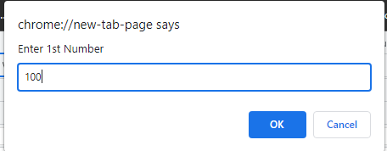var num1=parseFloat(prompt('Enter 1st Number'));

var num2=parseFloat(prompt('Enter 2nd Number'))

;var op=prompt('Enter Operator from + - \* /');

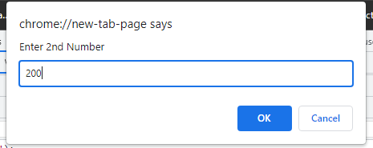if(op=='+'){var result=num1+num2;alert(result);}

else if(op=='-'){var result=num1-num2;alert(result);}

else if(op=='\*'){var result=num1\*num2;alert(result);}

else if(op=='/'){var result=num1/num2;alert(result);}

else{alert('Invalid Input !')}

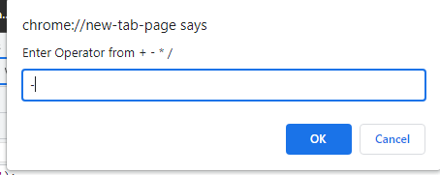

TASK NO 2

A.



B.

C.



D.

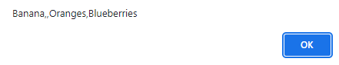

E.

TASK NO 3

var options=prompt('Alarm is Ringing!! Press S to Snooze and D to Dismiss !');

if(options=='S'||options=='s')

{while(options=='S'||options=='s')

{options=prompt('Alarm is Ringing!! Press S to Snooze and D to Dismiss !');}

alert('Wrong Input');}

else if(options=='D'||options=='d')

{alert('Good Morning')}

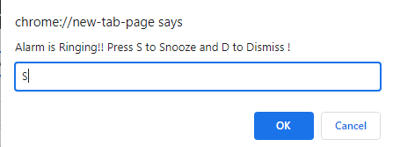else{alert('Wrong Input');}

